Memo

|  |  |
| --- | --- |
| To: | Troy Scevers |
| From: | Nathan Wiley |
| Date: | November 4, 2022 |
| Re: | Memo 5 |
|  |  |

This week I did a lot of finishing touches to the base of the telescope, the timesheet below lists the tasks completed each day:  
  


The schedule didn’t change much, I need to look at how I’m going to power the motors and order that, and I am not quite finished assembling the functional non-motorized telescope, but other than that, I am still on schedule.   


The tube rings got painted, and I got weather stripping from the hardware store. With that and the latches, they fit the tube perfectly and are very sturdy. Each ring can easily hold the weight of the telescope tube with the mirrors. All that is left for that portion is to drill holes to attach the middle piece between the two rings.

Below is a picture of the rings drying right after being painted:

Below is a picture of the rings fitted with latches and weather seal on the inner diameter. It holds the tube very securely without damaging the paint.

The triangle base also got a few coats of paint, and I reattached all the hardware that goes on it as well. All that is left for this part is to attach the leveling bubbles.

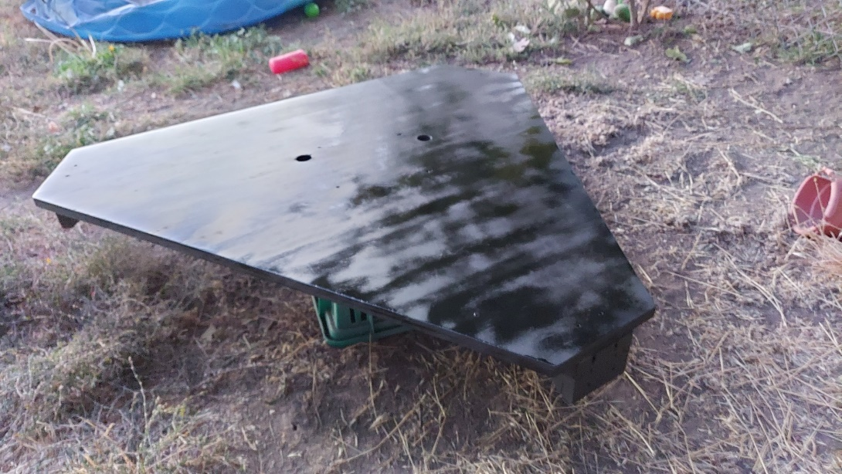

The main thing holding me back is the vertical axis. I am working on a method that uses a 6-inch wheel that rests on free rolling bearings, and then attach the driving mechanism (likely a belt) outside of that. I designed a part in Inventor, and I am currently 3D printing it. I hope that it will work because I would like to have already finished the assembly of the telescope mount. It isn’t too bad of a drawback however because I am still waiting on parts to arrive.

Below is a screenshot of the part I designed, and then that is an overlayed picture of how the wheel would sit on the bearings:

I am hoping that the 3D printed part will be able to hold the weight of the telescope. Once the parts are printed and I drill the holes in the upright pieces, I will be nearly finished with the entire mount and will be able to focus on the driving mechanisms.

My goal is to finish that by the 8th because there is a lunar eclipse, and I would love to take a decent picture of it.

This is a picture I manage to take while holding the telescope and aiming it by hand:

